Configuring RCP8 and PCAN-Ethernet Gateway DR to use UDP protocol
Aapo Hanski

Revision history

Revision | Date/Name | Description of change | Approver
A | 2025-01-23 Aapo Hanski | Initial instructions | Approver

Table of contents
1 Introduction 3
2 Configuring PCAN-Ethernet Gateway DR 3
3 Configuring RCP8 CANopen settings 6

Introduction
This document describes how to configure RCP8 and PCAN-Ethernet Gateway DR to use UDP protocol for CAN communication in Vaisala SSPA weather radars.
Before starting, make sure that IRIS/RDA version supporting UDP protocol for CANopen comunication is installed. These include versions 10.2.0 and newer, and patch versions 10.0.3 and 10.1.3.

Configuring PCAN-Ethernet Gateway DR
The PCAN-Ethernet Gateway DR is configured via its web user interface using a browser.
- Log in to the radar server on-site or using a remote desktop connection.
- Open Firefox web browser
- Type in the IP address (http://10.0.1.50 by default) of the PCAN-Ethernet Gateway in the address bar. You should see the following page:
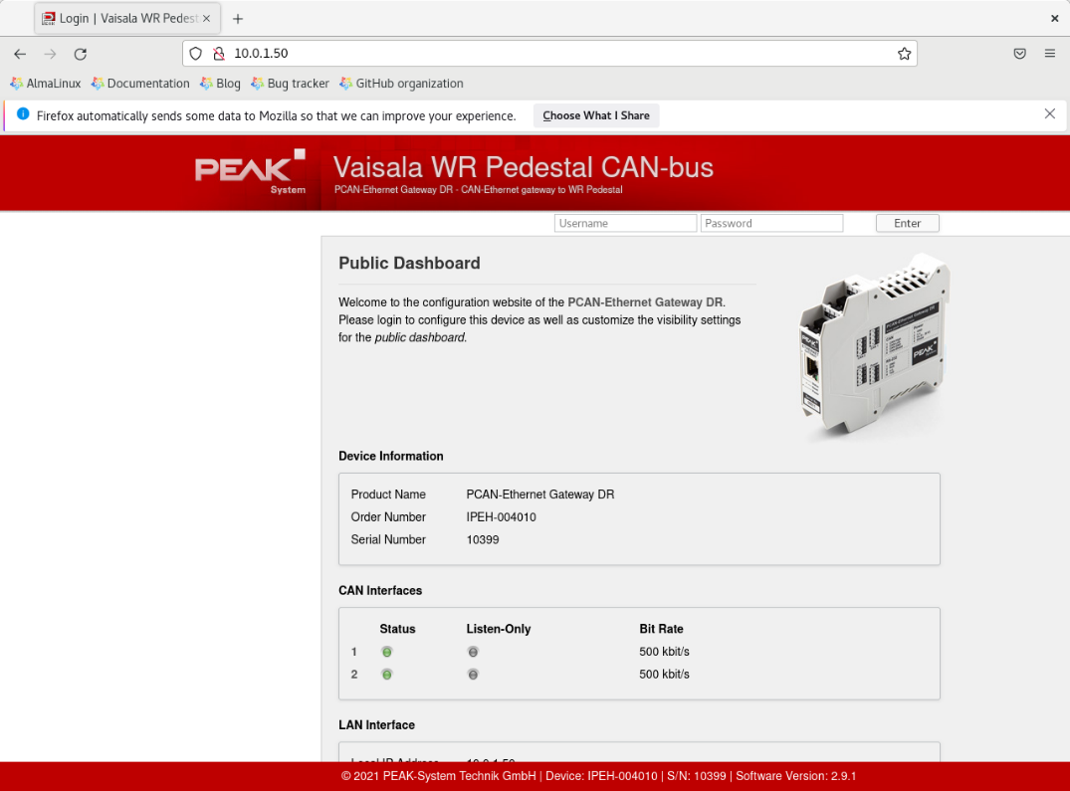
- Log in to the web UI. The username and password should be admin / Vaisala#1
- From the left side bar under ROUTING, select Manage Routes. You should see the following page:
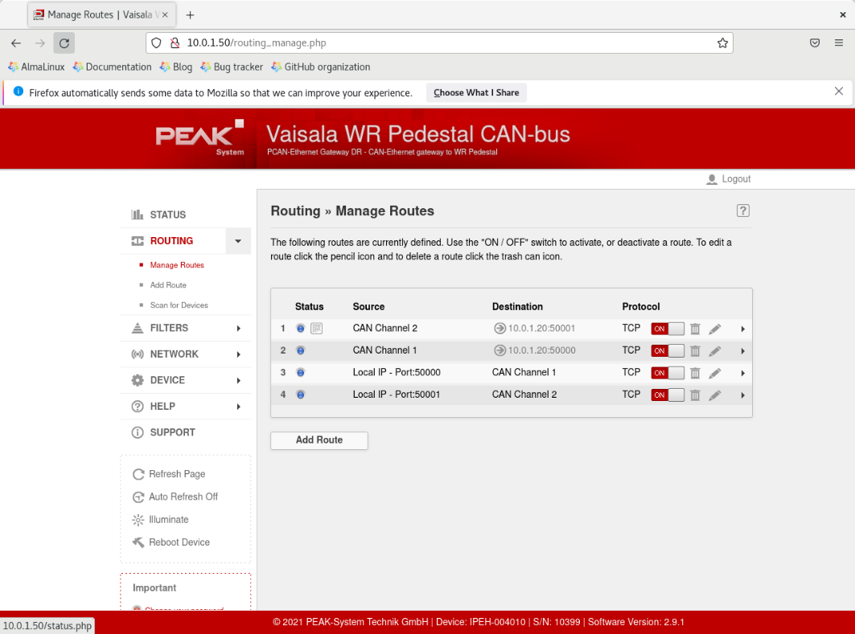
- From this screen, start editing the route with source CAN Channel 1 and destination 10.0.1.20:50000 by clicking the pencil icon on that row. On the route editing page, go to Step 4: IP Interface and select UDP as the protocol set Frames per Packet to 1. Press Save Settings at the bottom of the page.
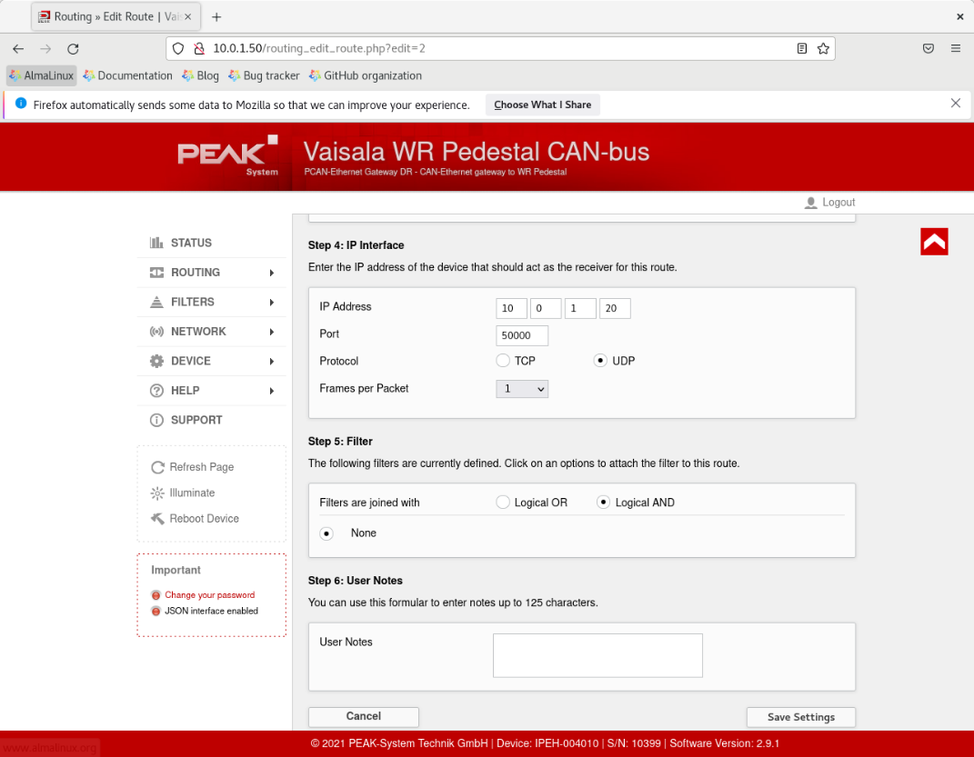
- From the page in item 5, edit the route with source Local IP – Port:50000 and destination Can Channel 1. Under Step 4: IP Interface, change to Protocol to UDP, and press Save Settings.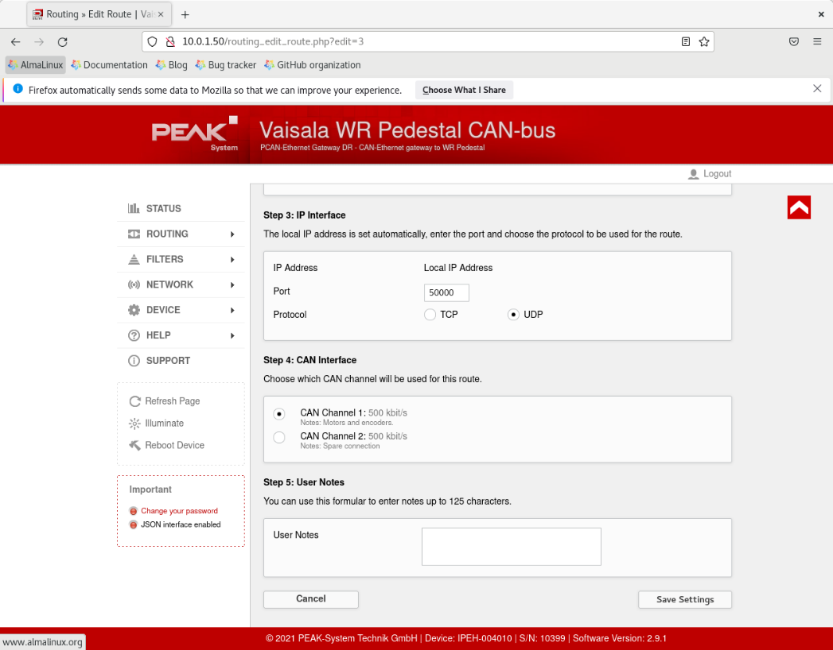
- Confirm that the routes related to CAN Channel 1 on the Manage Routes page look like the following:
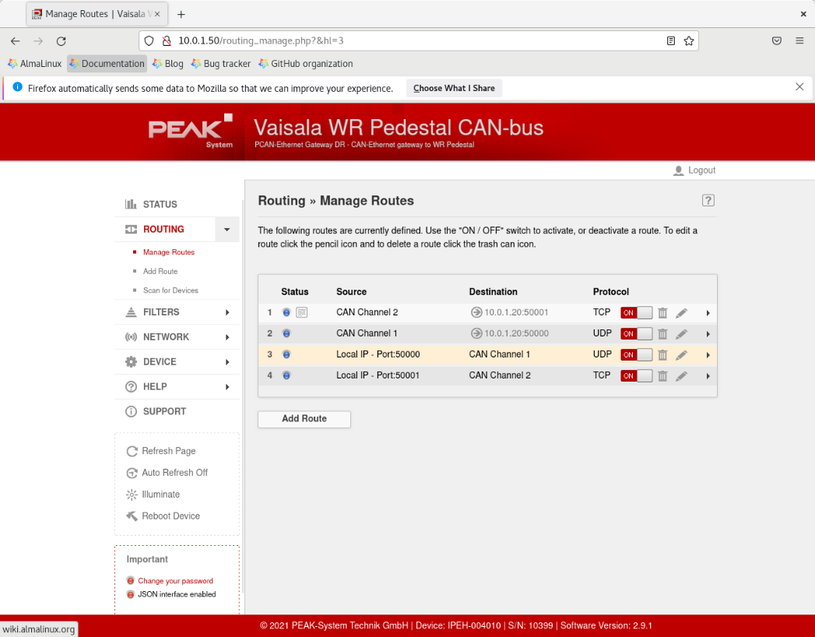
- CAN channel 2 routes can also be configured to use UDP, but it’s not necessary since CAN channel 2 is not used.

Configuring RCP8 CANopen settings
The CAN communication protocol for RCP8 is configured in the site custom menu of antx.
- Open terminal on the radar server as radarop
- Run antx
- Open the site custom menu with si cu
- Press enter until reaching the following prompt:
Choose: TCP UDP
CAN-bus Ethernet protocol: TCP New Value:
- Type in UDP and press enter
- Return to antx main menu with q
- Save the configuration with save command followed by y. antx should look like the following:
The following changes will be saved:
rcp8_nv.icanbus_eth_protocol : 0 ==> 1
y
Saving current settings... DONE
If the PCAN-Ethernet Gateway has also been configured to use UDP, the RCP8 logs should contain messages like the following (notice UDP protocol on the "Connecting" line):
22-JAN 15:44:52.136 CANopen/Vel: Connecting to Peak CAN-Ethernet gateway at address 10.0.1.50:50000 using UDP protocol
22-JAN 15:44:52.156 CANopen/Vel: Opened a connection to Peak CAN-Ethernet gateway
22-JAN 15:44:52.171 CANopen/Vel: AZ motor: node ID: 20, vendor ID: 00000082, product code: 00000200, revision number: 00000000, serial number: 015FBE7F
22-JAN 15:44:52.335 CANopen/Vel: EL motor: node ID: 21, vendor ID: 00000082, product code: 00000200, revision number: 00000000, serial number: 016F48F5
22-JAN 15:44:53.214 CANopen/Vel: AZ encoder: node ID: 30, vendor ID: 000000EC, product code: 0000000F, revision number: 00010009, serial number: 5284B084
22-JAN 15:44:53.962 CANopen/Vel: EL encoder: node ID: 31, vendor ID: 000000EC, product code: 0000000F, revision number: 00010009, serial number: 54D882B3
22-JAN 15:44:54.184 CANopen/Vel: All CANopen devices operational

